Our trading strategy involves selling 1% of our portfolio whenever prices rise and buying 1% whenever prices fall. This contrarian approach aims to take advantage of mean-reversion in stock prices. The chart below displays the daily performance of our strategy versus the S&P 500 index (SPY), used as our benchmark.

Our portfolio has generally captured market trends and has even outperformed the market over certain periods. However, during high volatility phases, the performance of the portfolio was subpar, failing to outpace the broader index. Furthermore, instances where the portfolio exceeded the market were less frequent compared to when it underperformed. The magnitude of outperformance was also limited, but underperformance was substantial. There is considerable room for further optimization.

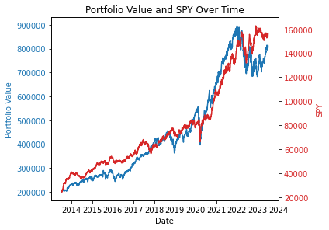

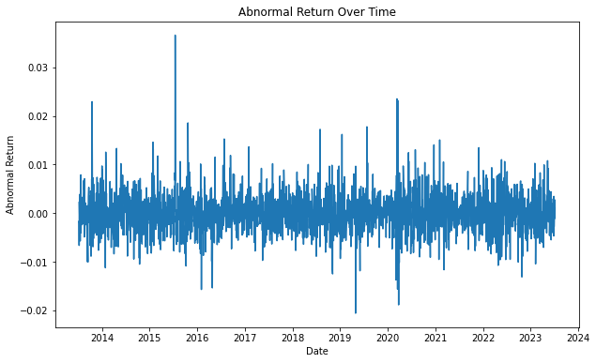

We also calculated the cumulative abnormal returns, which measure the returns of our strategy over and above the benchmark. The table below shows that our strategy has generated positive abnormal returns over the period.

|  |  |  |  |
| --- | --- | --- | --- |
|  | Mean_Return | Std_Return | Cumulative_Abnormal_Return |
| Portfolio | 0.000612 | 0.010736 | 0.221445 |
| SPY | 0.000776 | 0.009697 | NaN |

In summary, our trading strategy has shown potential to generate positive abnormal returns, especially during volatile market conditions. However, its performance tends to lag during trending markets. Future work could involve incorporating trend-following elements to improve performance during these periods.